**Chapter 8 Earned value management.**

Version 0.1.

1. **What is the EVM ?**

***Earned value management*** *is a project management technique for measuring project performance and progress in an objective manner.*

Essential features of any EVM implementation include

* A project plan that identifies work to be accomplished,
* A valuation of planned work, called Planned Value (PV) or Budgeted Cost of Work Scheduled (BCWS), and
* Pre-defined “earning rules” (also called metrics) to quantify the accomplishment of work, called Earned Value (EV) or Budgeted Cost of Work Performed (BCWP).

**EVM** implementations for large or complex projects include many more features, such as indicators and forecasts of cost performance (over budget or under budget) and schedule performance (behind schedule or ahead of schedule). However, the most basic requirement of an EVM system is that it quantifies progress using PV and EV.*

**BCWP Budgeted cost of work performed or EV** is the budgeted cost of work that has actually been performed in carrying out a scheduled task during a specific time period

**BCWS** **Budgeted Cost of Work Scheduled** the approved budget that has been allocated to complete a scheduled task during a specific time period.

**ACWP Actual Cost of Work Performed** the actual cost that has been spent, rather than the budgeted cost.

*To have more information, read below example.*

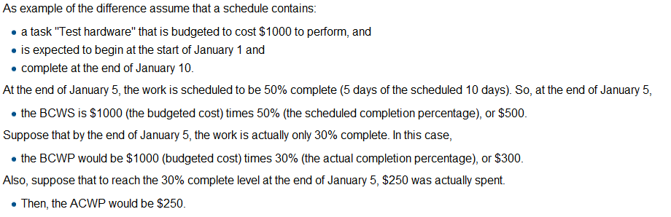

**SPI Schedule performance index**

**CPI Cost performance index**

**CV Cost variance**

**EAC Estimate at completion**

*We will use that method to determine project status (please read attach file)*

*(source Wikipedia) I have not enough time to do fully document so, you know.*